COMSATS University Islamabad
Department of Computer Science
CSC291 Software Engineering
Semester: Spring 2026
BS(AI) - Section 6A

Assignment No. 3 - Data and User Interface Design
Group No. 15

Project Title
ShareWay - AI Powered Peer-to-Peer Ride Sharing Platform

Submitted By:
Muhammad Awais Ali
FA23-BAI-028
Module: Communication, History & Reports Module

Submission Date: May 04, 2026

1. Project Overview
ShareWay is a cross-platform mobile application built with Flutter that facilitates peer-to-peer ride-sharing among urban commuters in Pakistan. The system uses Firebase for real-time backend services (Authentication, Cloud Firestore, Cloud Messaging) and OpenStreetMap for all map operations (Nominatim for geocoding, OSRM for routing). A weighted AI-driven matching algorithm scores potential rides on route similarity (40 percent), time overlap (30 percent), driver rating (20 percent) and pickup proximity (10 percent), so that passengers are connected to the most suitable drivers.
The application supports dual user roles (driver and passenger), real-time messaging, live GPS tracking, ratings & reviews, ride history, and four Pakistani payment methods (Cash, Easypaisa, JazzCash, Bank Transfer). The interface follows a dark glassmorphism design with a mint-green accent palette.

2. AI-Driven Techniques Applied
AI-driven techniques were applied at two levels: inside the product itself, and during the design process.

2.1 AI inside the product
These were designed by the team and are visible in the data design of every module:
- Weighted Ride-Matching Algorithm - a multi-factor scoring model that ranks candidate rides for each passenger query.
- Route Similarity via geo-spatial comparison - haversine distance and polyline overlap produce a 0-1 similarity score that drives the Rides collection schema.
- ETA Prediction - OSRM-derived duration is corrected using historical completion deltas stored on each ride.
- Sentiment-Aware Rating Pipeline - short reviews are classified positive / neutral / negative; results feed into the user trust score.
- Smart Notification Bundling - events from the same ride within a 60-second window are grouped into a single push notification.

2.2 AI used during the design process
The data design and UI specifications in this document were authored by the team. Figma's AI-assisted features (auto-layout, content fill, component-name hints) were used as a lightweight aid to keep spacing, typography and naming consistent across screens. All validation rules, navigation flows and entity-relationship choices are the team's own work.

3. Communication, History & Reports Module
This module owns in-app messaging, push notifications, ratings and reviews, ride history, and all user-facing analytical reports. It consumes data from the Authentication and Ride Management modules.

3.1 Data Design
Five collections back this module: chats (with a messages subcollection), ratings, notifications (per-user subcollection), and rideHistory (read-only derived view written by a Cloud Function on ride completion).
Entity: chats
Attribute | Type & constraints | Description
chatId | string (PK) = rideId | One chat per ride
participantIds | array<string>, >= 2 (FK -> users.uid) | Driver + accepted passengers
lastMessage | string, <= 250 chars | For chat-list preview
lastMessageAt | timestamp (server) | Used to order the chat list
unreadCounts | map<uid, int>, auto-updated | Drives the unread badge
Entity: chats/{chatId}/messages (subcollection)
Attribute | Type & constraints | Description
messageId | string (PK), auto-id | Document ID
senderId | string (FK -> users.uid) | Author
text | string, 1-1000 chars, moderated | Body
sentAt | timestamp (server) | Sent time
readBy | array<string> | Read receipts
systemFlag | enum: user | system | System rows mark status changes
Entity: ratings
Attribute | Type & constraints | Description
ratingId | string (PK), auto-id | Document ID
rideId | string (FK) | The completed ride
raterId | string (FK), != rateeId | Submitter
rateeId | string (FK) | Receiver
stars | int 1-5 | Score
comment | string, <= 250 chars, moderated | Optional review
sentiment | enum: positive | neutral | negative | AI auto-tag
role | enum: driver_rates_passenger | passenger_rates_driver | Direction
createdAt | timestamp (server) | Submission time
Entity: users/{uid}/notifications (subcollection)
Attribute | Type & constraints | Description
notificationId | string (PK), auto-id | Document ID
type | enum (request, accept, reject, message, ride_started, ride_completed, rating_received) | Drives icon and deeplink
title / body | string, <= 60 / 240 chars | Push title and body
payload | map (rideId, chatId, ...) | Routing info
read | bool, default false | Toggled on tap
createdAt | timestamp (server) | Sort key
Entity: rideHistory (derived view)
rideHistory is materialised by a Cloud Function on ride completion. Each completed ride generates one history document per participant so that the 'rides where I was driver' and 'rides where I was passenger' queries are both fast and use a single index.
Attribute | Type & constraints | Description
historyId | string (PK), auto-id | Document ID
rideId | string (FK) | Source ride
userId | string (FK) | The participant
role | enum: driver | passenger | View tab in Ride History
origin / dest | GeoPoint + address (frozen at completion) | Snapshot of route
seats | int >= 1 | Seats taken / offered
fare | double >= 0 | Final agreed fare
paymentMethod | string | How it was paid
completedAt | timestamp (server) | When ride ended
status | enum: completed | cancelled | Outcome
summary | string, AI-generated | One-line trip recap
AI components in this module:
- Sentiment Tagging - short reviews are classified positive / neutral / negative; the average sentiment is exposed alongside the user's star rating.
- Content Moderation - chat messages and review comments pass through a profanity / abuse classifier; flagged content is hidden behind a 'Show anyway' tap.
- Smart Notification Bundling - same-ride consecutive events within 60 seconds are bundled into a single push.
- Trip Summary - a one-line summary of each completed ride is stored on the rideHistory doc (e.g. 'Smooth 12 km ride from G-8 to F-10, on time').

3.2 User Interface Design
The module covers seven screens spanning chat, ratings, history and notifications.
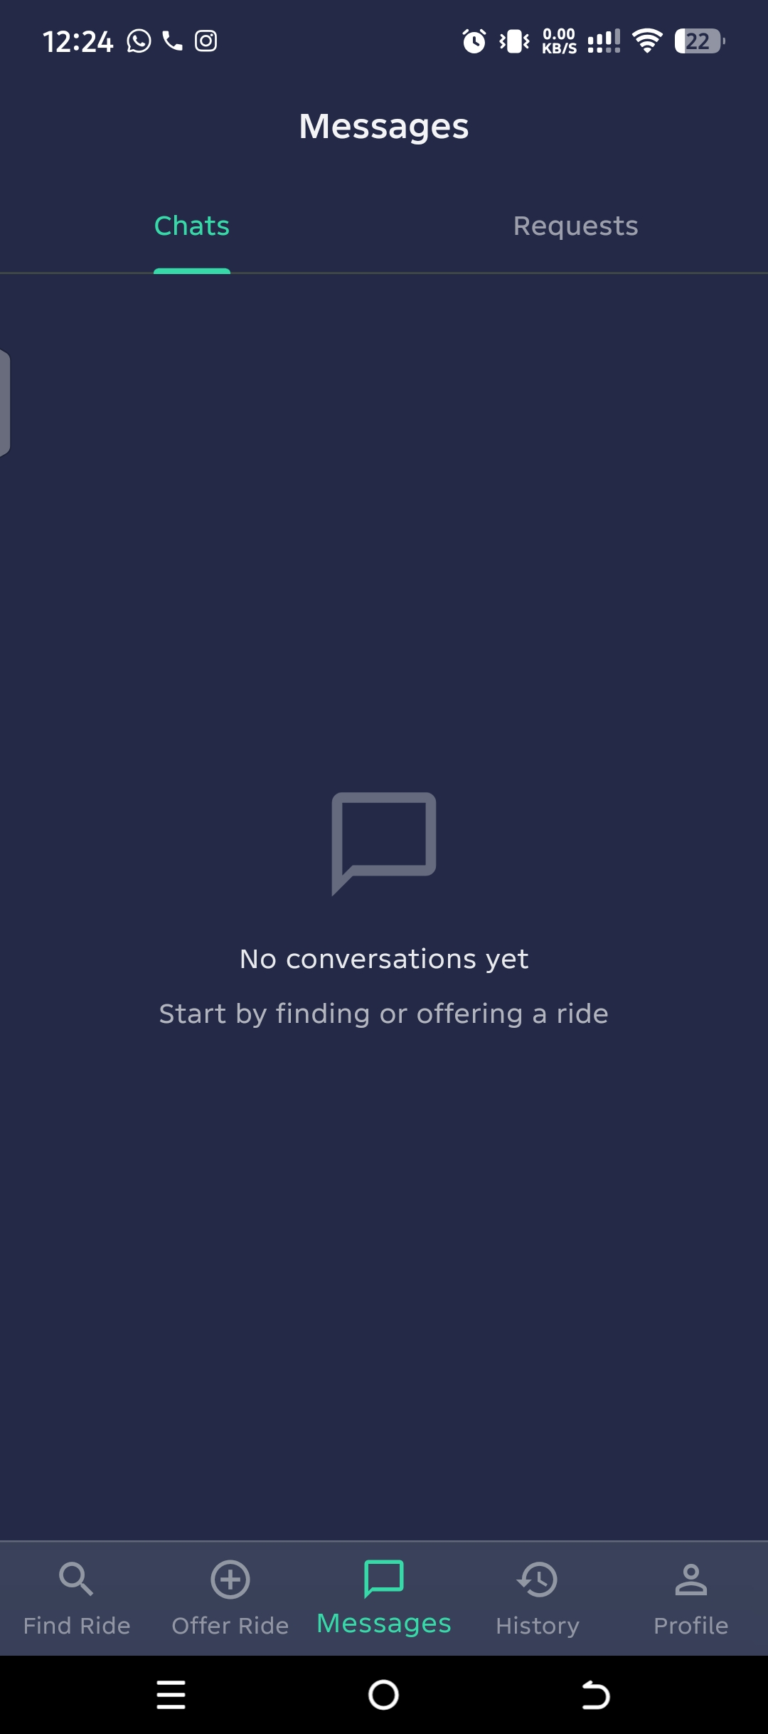 | 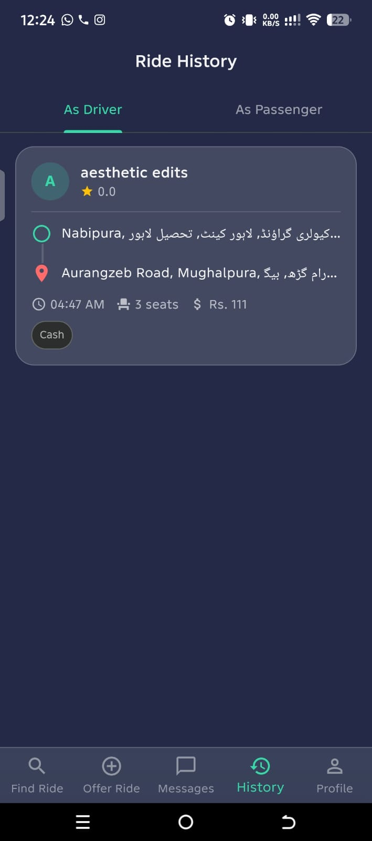
Messages screen (Chats / Requests tabs) | Ride History screen (As Driver / As Passenger)

Screen 1 - Messages List (Output)
Two-tab inbox: in-ride chats on the left, pending ride requests on the right.
Inputs and controls:
- Tab - Chats: default tab, shows chats where the user is a participant.
- Tab - Requests: convenience tab pulling from rides/{rideId}/requests where the user is the driver and status = pending.
Outputs and states:
- Each chat row - avatar, name, last message, timestamp, unread badge.
- Empty state - chat-bubble icon, 'No conversations yet - Start by finding or offering a ride'.

Screen 2 - Chat Conversation (Input + Output)
Realtime ride-specific chat backed by Firestore streams.
Inputs and controls:
- Compose box: multiline text input, 1-1000 chars.
- Send: icon button - writes the message and bumps lastMessage.
Outputs and states:
- Mine bubbles in mint on the right, theirs in grey on the left.
- System messages centered (e.g. 'Driver started the ride').
- Read receipts - single tick = sent, double tick = read.
- Offline banner - 'You are offline. Messages will be sent later.'.

Screen 3 - Ride History (Output)
Per-user log of completed and cancelled rides, split into As Driver / As Passenger tabs. The screenshot above shows the As Driver tab; the figure below shows a richer detailed view used for analytics.
Outputs and states:
- Tabs - As Driver, As Passenger.
- Per-card - origin, destination, time, seats, fare, payment chip and AI Trip Summary.
- Tap a card - opens read-only Ride Details with a 'Rate now' CTA if not yet rated.
- Empty state - 'No rides yet' icon and CTA.
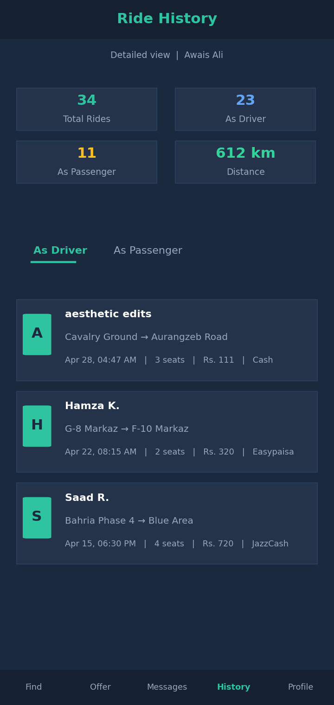
Ride History - Detailed View (analytics layout)

Screen 4 - Rate & Review (Input)
Captures a star rating and optional review at the end of a ride.
Inputs and controls:
- Stars: tap-to-select 1-5, integer required.
- Review text: multiline text input, <= 250 chars, moderated, optional.
- Quick chips: multi-select: Polite, On-time, Clean car, Smooth ride.
- Submit Review: primary button - writes the ratings document and updates users.rating.
- Skip: text button - dismisses; CTA reappears in History.
Outputs and states:
- Snackbar 'Thanks for your feedback'.
- Sentiment tagging runs asynchronously and sets ratings.sentiment.

Screen 5 - Notifications (Output)
Per-user notification list with deeplink-on-tap.
Outputs and states:
- Type-specific icon and color for each row.
- Bold title if unread; relative time (e.g. '5 min ago').
- Bundle pill - '+2 more from this ride' when bundled.
- Empty state - bell icon and 'You are all caught up'.

Screen 6 - Push Notification (System Output)
OS-level banner delivered via Firebase Cloud Messaging using the user's stored fcmToken.
Outputs and states:
- Banner title and body from the notifications document.
- Tap action deeplinks via notifications.payload.
- Quiet hours (default 22:00-07:00) - silent push only.

Screen 7 - Notification Settings (Input)
User preferences page that writes to users.notificationPreferences.
Inputs and controls:
- Ride Requests: toggle, default On.
- Messages: toggle, default On.
- Ride Started / Completed: toggle, default On.
- Ratings Received: toggle, default On.
- Marketing: toggle, default Off.
- Quiet Hours: time-range picker, default 22:00-07:00.
- Save: primary button - writes the diff.
Outputs and states:
- Snackbar 'Preferences saved'.

3.3 Reports
Four reports - two are user-facing (Driver Earnings and Passenger Spend), one is shared (Ratings Summary), and one is admin-only (Platform Statistics).

Report 1 - Driver Earnings
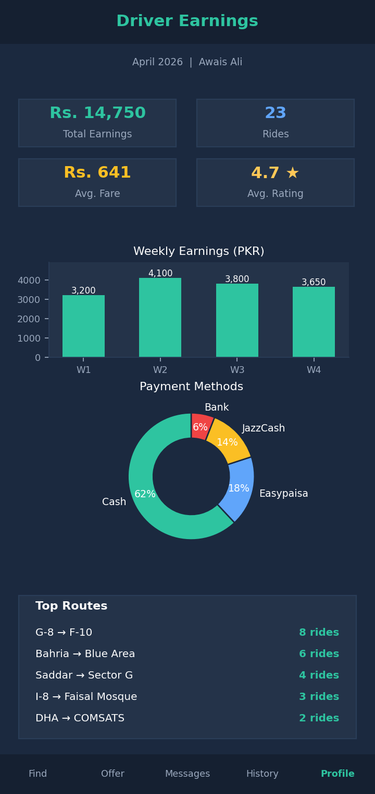
Driver Earnings Report (per-driver, period-filtered)
Metrics included:
- Total earnings - sum of rideHistory.fare where role = driver and status = completed.
- Rides completed and average fare per ride.
- Weekly earnings bar chart for the period.
- Payment method breakdown (donut).
- Top 5 routes by ride count.

Report 2 - Passenger Spend
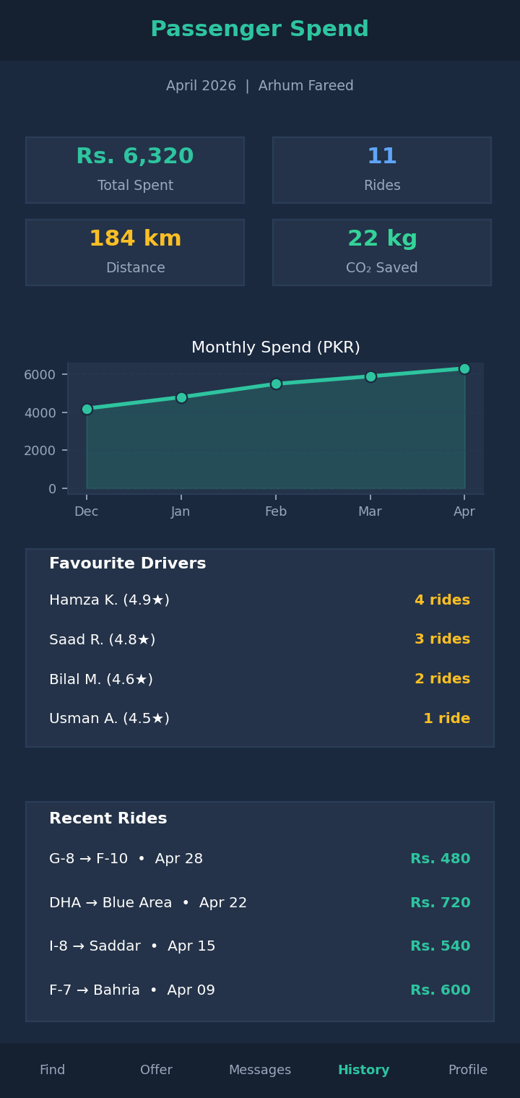
Passenger Spend Report (per-passenger, period-filtered)
Metrics included:
- Total spent, rides taken, distance travelled and CO2 saved (distance * 0.12 kg/km baseline).
- Monthly spend trend line.
- Favourite drivers by ride count and average rating.
- Payment methods used and recent rides.

Report 3 - Ratings Summary
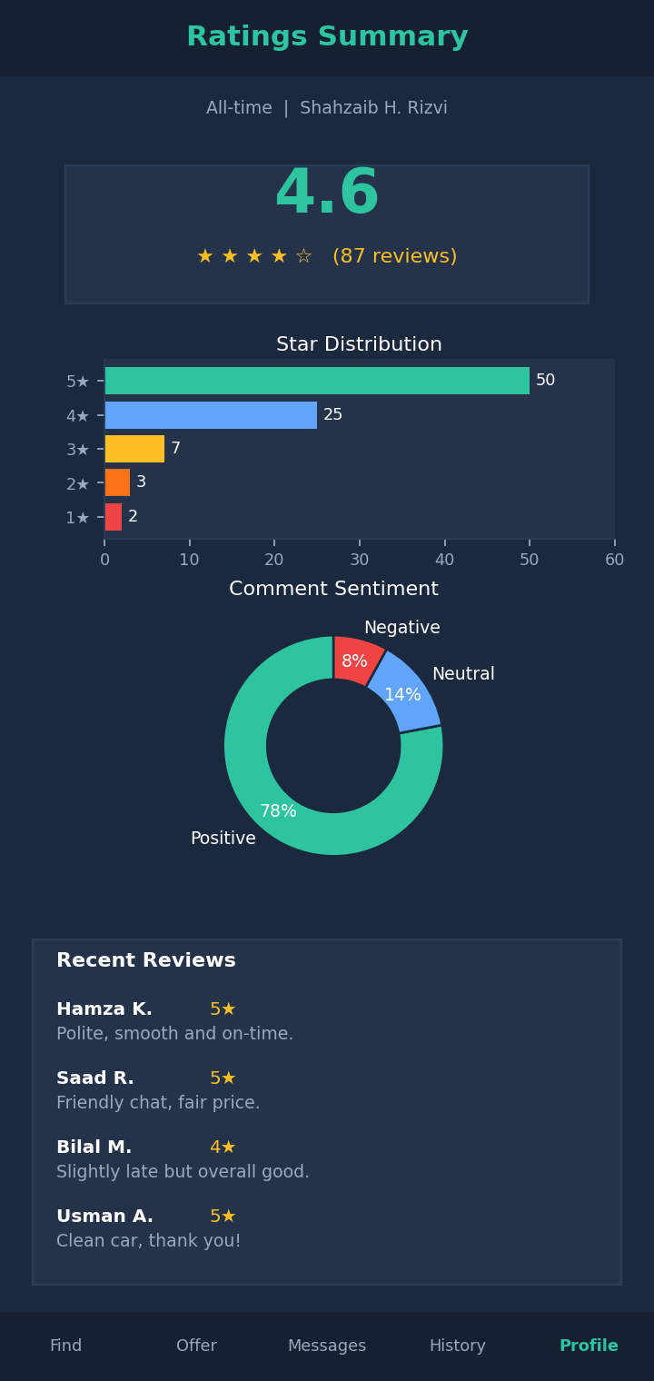
Ratings Summary Report (per-user, all-time)
Metrics included:
- Average star rating with review count.
- Star distribution (1-5 horizontal bars).
- Sentiment distribution (donut) - positive / neutral / negative.
- Trust score over time (line chart).
- Top quick chips received and recent reviews.

Report 4 - Platform Statistics (Admin)
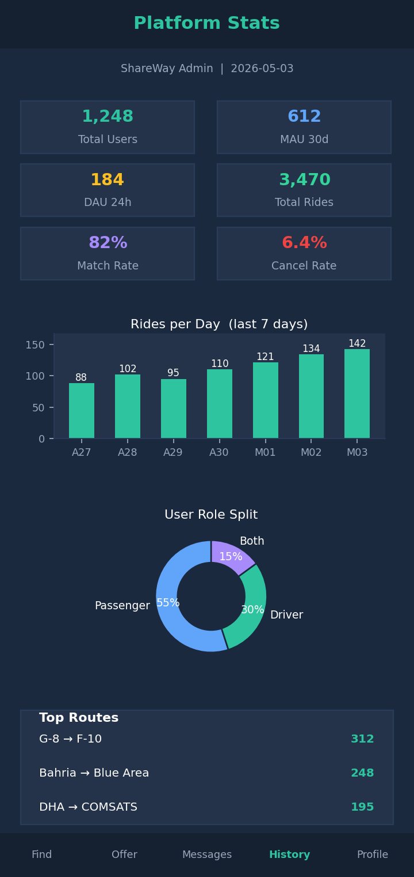
Platform Statistics Report (admin dashboard)
Metrics included:
- Total users, MAU, DAU, total rides and match success rate.
- Rides per day for the last 7 days.
- User role split (donut).
- Top 6 platform-wide routes with mini bar comparison.
- Operational health - average match score, search-to-match latency, cancellation rate, average trip rating, active rides and pending requests.

3.4 Personal Contribution - Awais (FA23-BAI-028)
- Designed all five entities for messaging, ratings, notifications and the derived rideHistory view, including denormalisation choices that keep history queries one-index-deep.
- Specified the four AI components in this module (sentiment tagging, content moderation, smart bundling, trip summary) and mapped each one to a concrete data field.
- Authored UI specifications for the seven communication and history screens, including empty-state and offline-state behaviours.
- Designed the four reports (Driver Earnings, Passenger Spend, Ratings Summary, Platform Statistics) and produced their mock-ups.

4. Group Work Distribution Summary
The assignment was split module-wise so that each member owns the data design, UI design and reports for their module end-to-end. Cross-module identifiers (uid, rideId) were agreed in joint sessions before each member began their detailed work.
Shahzaib (FA23-BAI-050) - Authentication, Profile & Vehicle Management.
- Entities: users, users/{uid}/vehicles, passwordResetAudit.
- UI screens: Login, Sign Up, Reset Password, Profile, Edit Profile, Add / Edit Vehicle.
- Report: User Registration & Activity (admin).
Arhum (FA23-BAI-006) - Ride Management.
- Entities: rides, rides/{rideId}/requests, liveTracking, plus the AI matching algorithm specification.
- UI screens: Offer Ride (one-time and recurring), Find Ride, Map Picker, Search Results, Ride Details, Send Request, Driver Inbox, Active Ride / Live Tracking.
- Report: Active Rides Snapshot (admin).
Awais (FA23-BAI-028) - Communication, History & Reports.
- Entities: chats, messages, ratings, notifications, rideHistory, plus four AI components (sentiment, moderation, bundling, summary).
- UI screens: Messages List, Chat, Ride History, Rate & Review, Notifications, Push Notification, Notification Settings.
- Reports: Driver Earnings, Passenger Spend, Ratings Summary, Platform Statistics.

